**PAM Final Report**

1. **Abstract**

The goal of this project was to produce a new, more up to date website, or update the existing website so that it includes more functionality such as video capability, member functionality, calendar and event tracking, etc. In addition to this we examined their current infrastructure to determine if any upgrades were required. We also provided documentation for their infrastructure and website, enabling anyone to be able to maintain the website and network on their own without needing to consult us at a later date. This product as specified by Dick, is intended to have 3 different users. The first user will be the person(s) responsible for maintaining the website post-development and performing and further upgrades after we have completed our project. The secondary user in terms of this project will be the hosts who must interact with the website, software and hardware on a daily basis. The main focus here is ensuring that proper documentation is written during the development process so that this specific tier of user can easily learn how to use the software with minimal to zero prior existing knowledge. The third and largest user group that this project is meant for is the end user. The end user represents any and all visitors/potential visitors that interact with the website and infrastructure. The website in particular, should be intuitive and easy to follow, and include a retroactive and intuitive design.

1. **Introduction**

The infrastructure needed a rework from what it was. It was very basic and needed a better and more updated design since it seemed to be outdated. The problem was that their system needed a rework. They also did not have the knowledge for their current system so they wanted us to provide documentation for what we do so they can maintain it for the future as well. The solution to this issue was that we are going to work closely with Dick Briggs and his team at PAM to ensure the system they have is updated and also able to maintained by current and future staff through the documentation we provide.

1. **Motivation**
2. This problem was interesting to us as a group because PAM seems to have every aspect of our majors contained in it, but it also seemed like the Prairie Aviation Museum needed assistance to provide a better user experience for their museum attendees. The problem was also that the structure was created by someone who retired so updating their system was difficult for the current staff since they do not have any information on how it works.
3. This problem occurs since the system was hard to update without an entire rehaul because the current staff do not have the knowledge from the previous staff. It was constant since the staff is not sure what the previous worker created, but they tried to maintain it over time.
4. The problem wasn’t solved, but they were running on old systems because they can make it work. This does not mean it was alright because old systems can have vulnerabilities to their security and they also provide a slower experience to the users too.
5. There are improvements. We created a website and tried to modify the current website to see which format they liked better. We also needed to map out the network and see if users will need more bandwidth or if the current provider was alright. Another improvement we tried to make was to implement a way for a user to click a picture on the website and have a video play.
6. **Related** **Work**
7. There are other websites out there. We wanted to roughly emulate certain aspects of these sites to make the experience better for the users Prairie Aviation Museum. Also, for network stability and security, things like a home network is similar to what we wanted to achieve at PAM, but on a bigger scale.
8. **Project Details**
   1. *Architecture and Environment*

They have an Office PC, two pocket PCs for displays, a TV streaming chromecast from their chromebook and a flight simulator. May need to upgrade network infrastructure (e.g. new provider, separate wi-fi networks, etc). We also may need to have a database set up, MySQL or MondoDB. HTML, PHP, CSS or website builder tool for the future website. We may also use things to test network stability and network security.

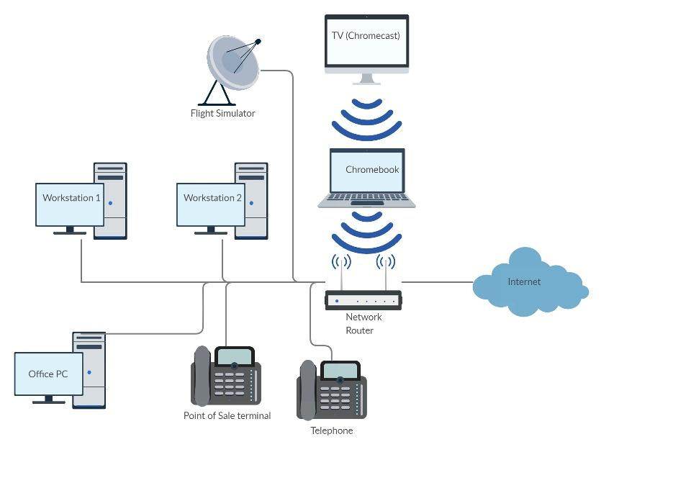

**Figure 1: Network Diagram of PAM’s infrastructure.**

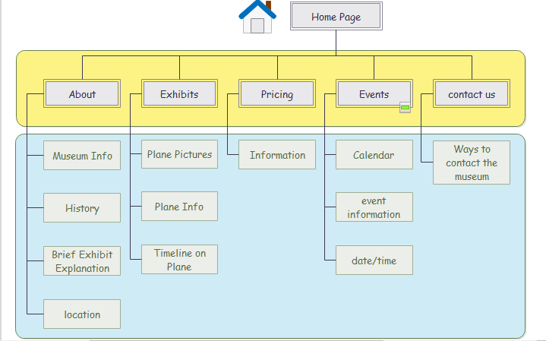

**Figure 2: Software Diagram for the Website.**

* 1. *Accomplishment*
     1. While working with PAM, we had two on-site meetings. During the second meeting, we helped Dick and his crew fix their interactive displays. Before we arrived, they were not loading some of the interactive displays. This was due to there being no system clean-up of temporary files when shutting down the displays. This wasn’t in our project scope, but Dick and his team said this made our team working with them worth it already. We also got the wireframe designs for the website approved from our Zoom meeting on Thursday, March 26th. We took multiple ideas and presented what they liked or didn’t like and came to a consensus on what we would like to create going forward! This wireframe led to the development of the functioning website for PAM’s future web development! PAM has discussed as time went on that they would like templates for their website so they can easily add in their information and do minor styling editing.
     2. In addition to the on-site accomplishments we were able to set out what we originally intended to do and design a new website for the PAM team. This website features a more modern feel with better navigation and easier to find information. With that being said however, we had to make some compromises and decided that WordPress would not be the best choice for building the website since it requires a monthly fee for certain features and without these features lacks customization. Instead we elected to go with a more classic approach by using CSS, HTML, and JavaScript. In addition to the website, we intend to provide proper documentation to ensure that the PAM team can adequately keep their website up to date and add additional webpages if needed.
     3. Below are example pictures of the functioning website.

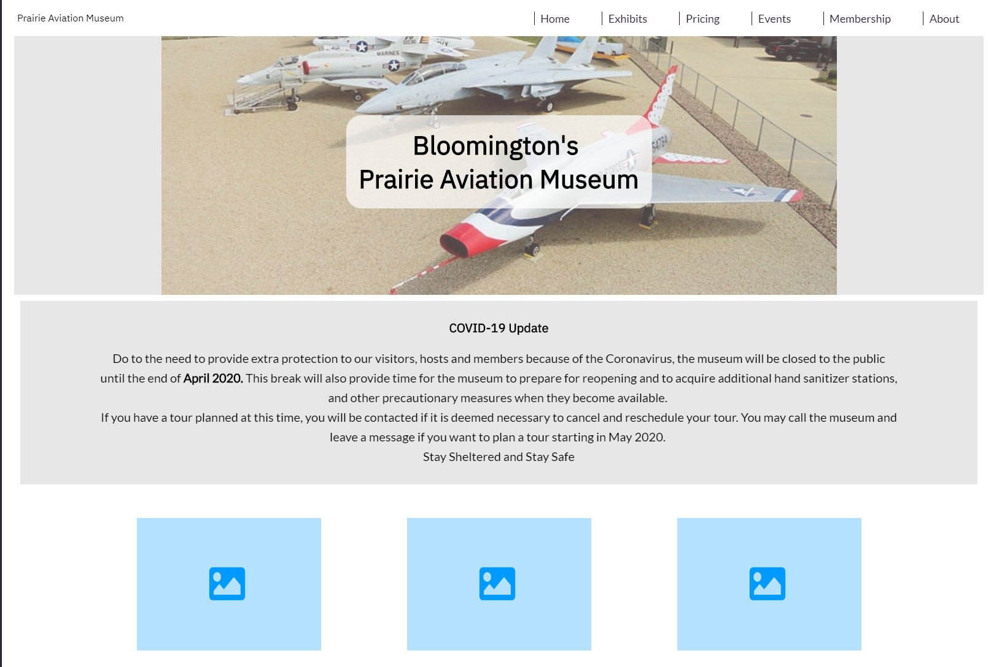

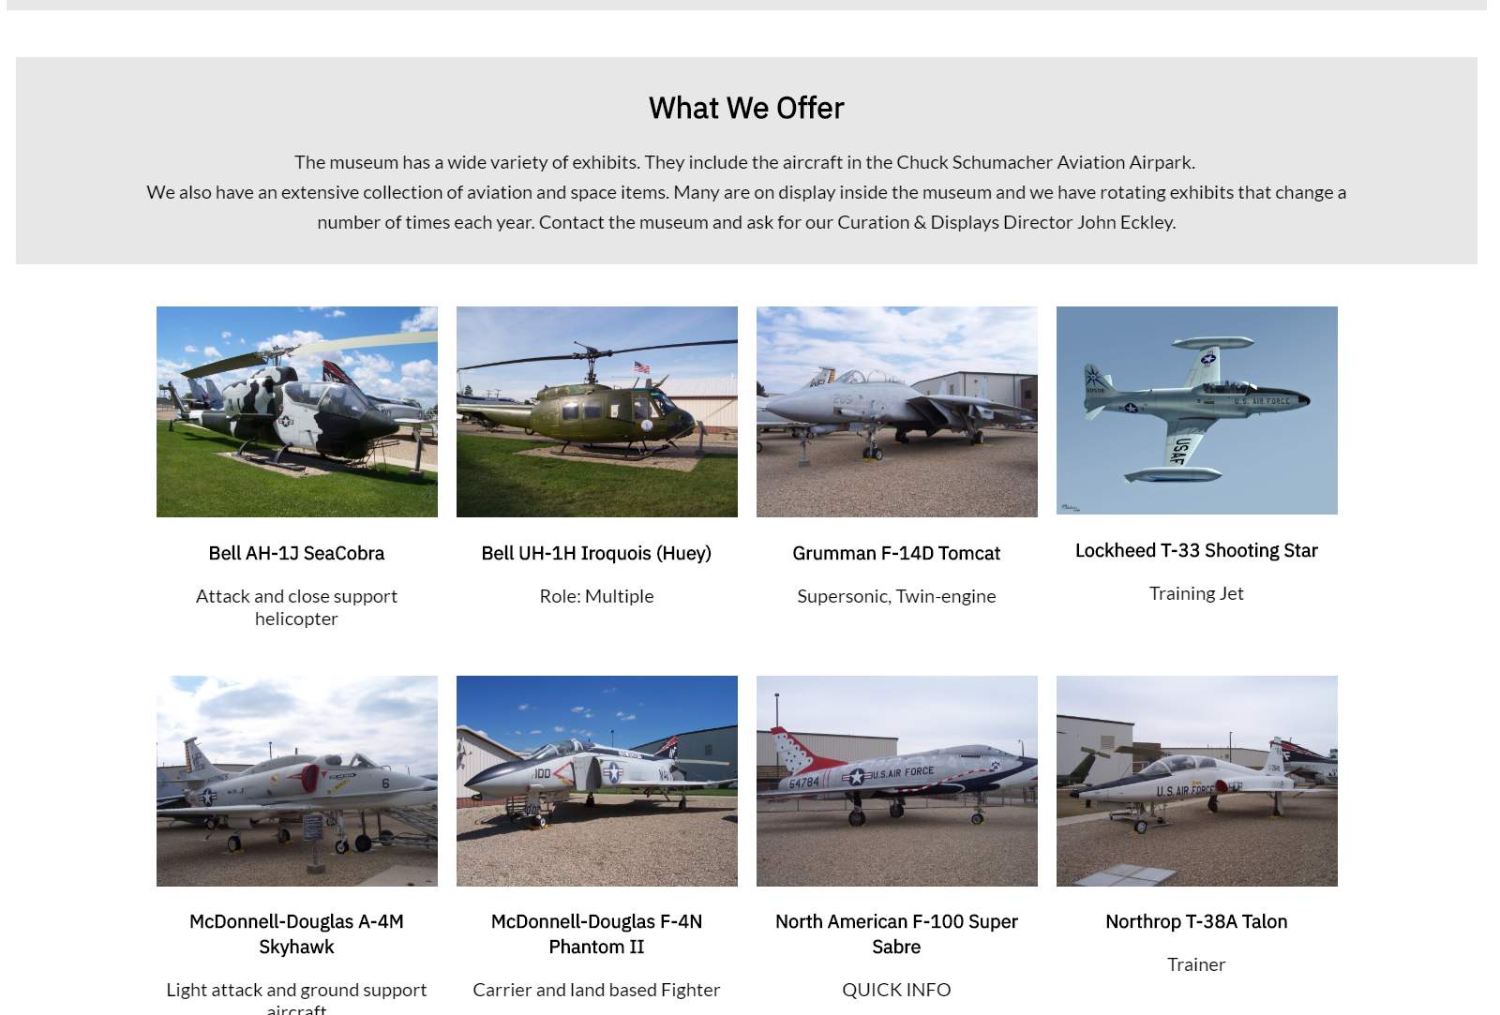

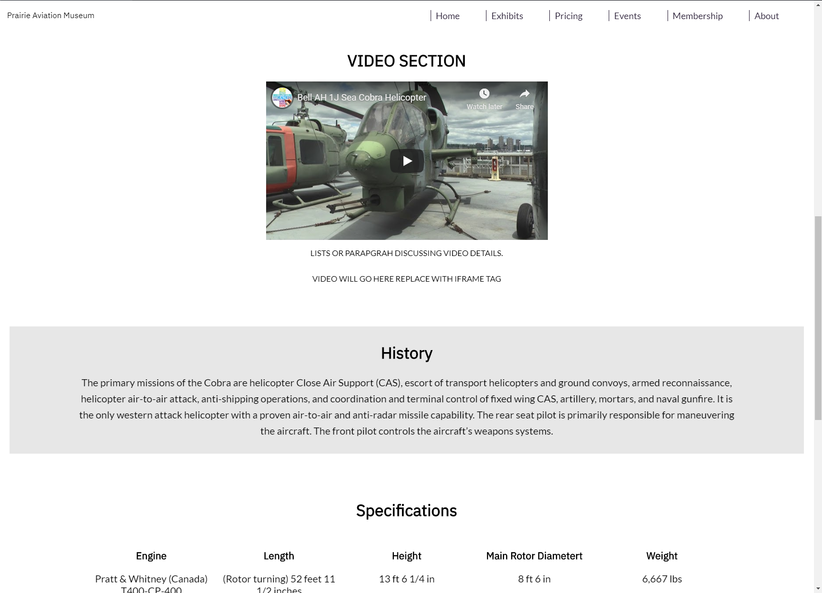

* 1. *Implementation Issues and Challenges*
     1. These are some of the issues and challenges we encountered during the process. The first issue was that the PAM team was locked out of their security camera system from a forgotten password. This halted progress with this aspect of the project until they were able to obtain the password and proceeded with the plan to get them up and running. We also had trouble finding the right design that we liked and was feasible during the time constraint. Since PAM wanted to see many different designs a head of time, it took longer to come up with one that works well with them and us. Writing the documentation so anyone could follow it once the semester is over will need to be written very well so there’s no room for questions or errors. How are we using or extending current tools/systems for our problem? Research how to implement WordPress templates. This particular project requires some knowledge of several different IT fields- namely web development and network management. The group will have to work on several different aspects of the needed deliverables at once. It may be difficult to sync one part of the project to the others, and to help out the others when necessary. We had to create documentation that is clear to the website personnel, since our group will not be able to maintain the website or network after the project finishes. The project is unique because it involves different aspects of technology and it will be used in the future so we can always look back and see what we created. Finding a way to implement a timeline with features with the airplanes also took some time to complete since this task wasn’t easy for our group.
     2. Another issue we encountered was in regards to the website and revolved around the use of WordPress when it came to designing it. When attempting to migrate our custom code to WordPress we realized that to use certain types of custom code (mainly CSS) we would have to buy a premium license. We decided that since we wanted to try and minimize costs it was best to not go this route.
  2. *Deliverables*
     1. The project will produce a modular website/templates that is easy to edit for those without IT or web development experience.
     2. Documentation for the website to aid in upkeep and maintenance. Streamlining and upgrades of on-site network infrastructure. Documentation for maintaining and upgrading the on-site infrastructure, network, and devices. Possible stretch goal: Setting up the on-site security cameras to a feed accessible from off-site (Provided in a separate document).
     3. Setting up the on-site security cameras to a feed accessible from off-site computers.
  3. *Evaluation* 
     1. The results we came out with exceeded our original plan of just creating a website for the PAM team. When we took on the project, we expected to just be building a website for a local museum but our visits before the pandemic had us exceeding what we set out to do. The extra things we provided PAM with were helping them have their interactive systems close and start properly so that the presentations would play properly on every startup. We also worked with them to make sure their security camera system is in the process of being up and running while they did the work behind the scenes since we couldn’t be there to do so. The way we will help keep the success of these things we have done is by providing them documentation that shows our experience to make sure they can use it and test it to make sure everything works as they intend it to.

1. **Conclusion**
   1. Our project was completed successfully and it will provide us and PAM with great knowledge for the future for both the museum and our experience as well. We chose this project since it highlights all of our majors and the solution to the issues was lined out by Dick Briggs when he proposed the project to us. Our planned contributions are to provide a better website for the museum, see what upgrades the infrastructure needs, regarding network and security functions, and security monitoring (physical security). COVID-19 did not help us complete our stretch goals that we had in mind, but the goal we set out to complete from the start has been accomplished.
2. **References**
   1. https://www.webcreate.io/website-builders-comparison-usa/?edgetrackerid=100316167373353&gclid=CjwKCAiA98TxBRBtEiwAVRLqu9eXb1OEXVByBVEmxShEpbkhDX-s_ARRQHDQFfbn5_hc2d1SJRItuRoCLaIQAvD_BwE
   2. https://prairieaviationmuseum.org/about-us/history-of-pam/
3. **Workload** **Distribution** **among** **Team** **Members**
   1. Seth and DJ as computer science majors and Ashley as web development, we have the ability to revamp the website, Claire in telecommunications will be able to assess the current network diagnostics and determine if upgrades are needed, and Zach will be able to examine possible security concerns.
4. **Your sponsor name:** Dick Briggs (Prairie Aviation Museum)